.

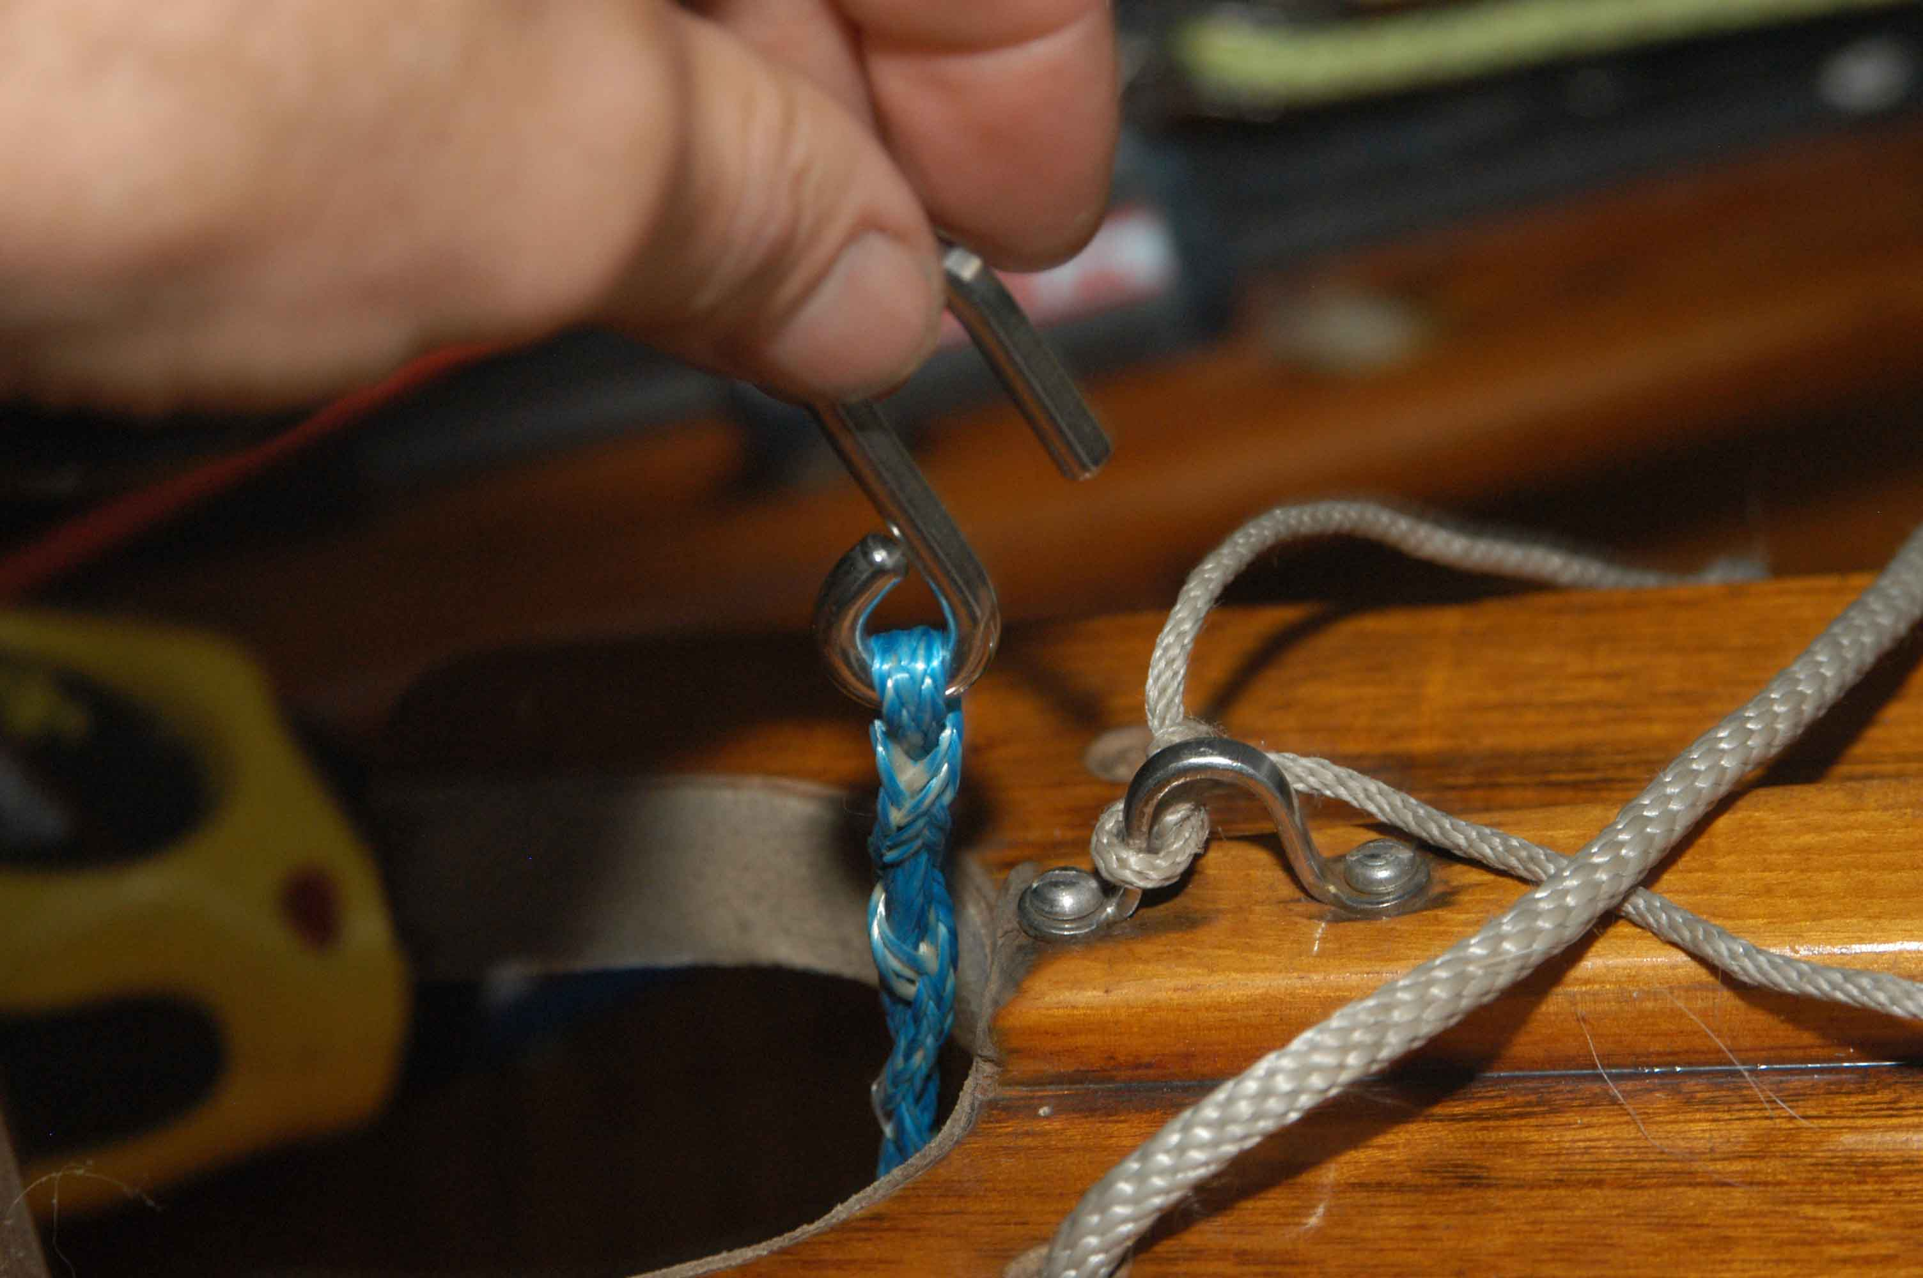

Cunningham – hook spliced to line. I drilled a hole through boom (where eye strap on boom was).

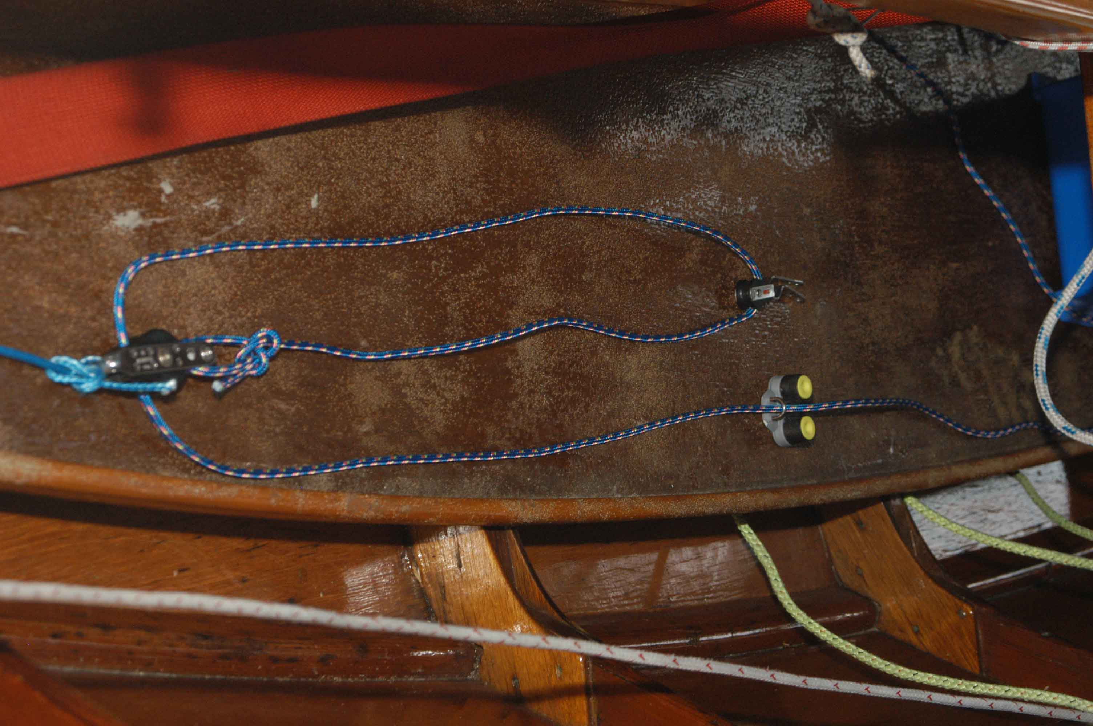

Rest of system for Cunningham. Will be on opposite side of boat from boom vang. Eye strap mounts under thwart and cleat at end of centerboard trunk. (I may have spliced an eye to attach low stretch line to bullet block with becket.

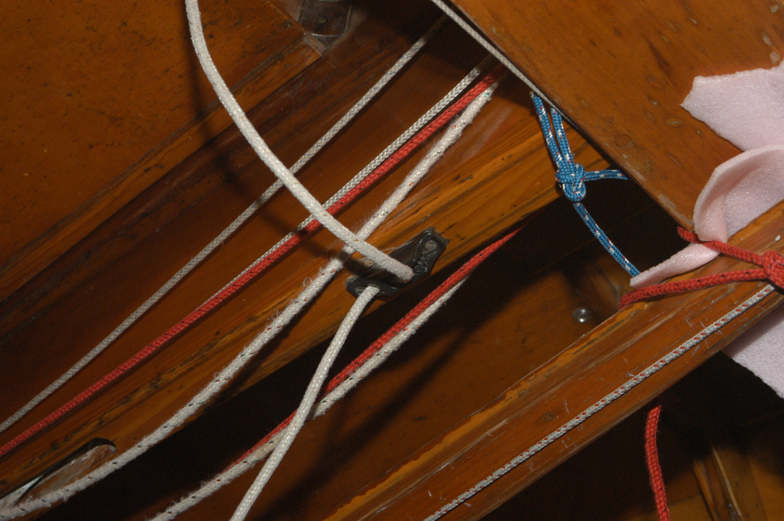

Alternative arrangement for centerboard cleat. I provided a similar cleat plus separate black fairlead which you might want to use if you want to use the cam cleat for the shroud or something.

There is a second cleat – black with a red round part, which I used to use for control lines (e.g. Cunningham).. Line is captive, and these work well at the end of the centerboard trunk (put in on the side where the cleat is toward the top.
It doesn’t matter which side you lead the vang and Cunningham to. I set the vang up to cleat on the starboard side, but this can be changed easily.

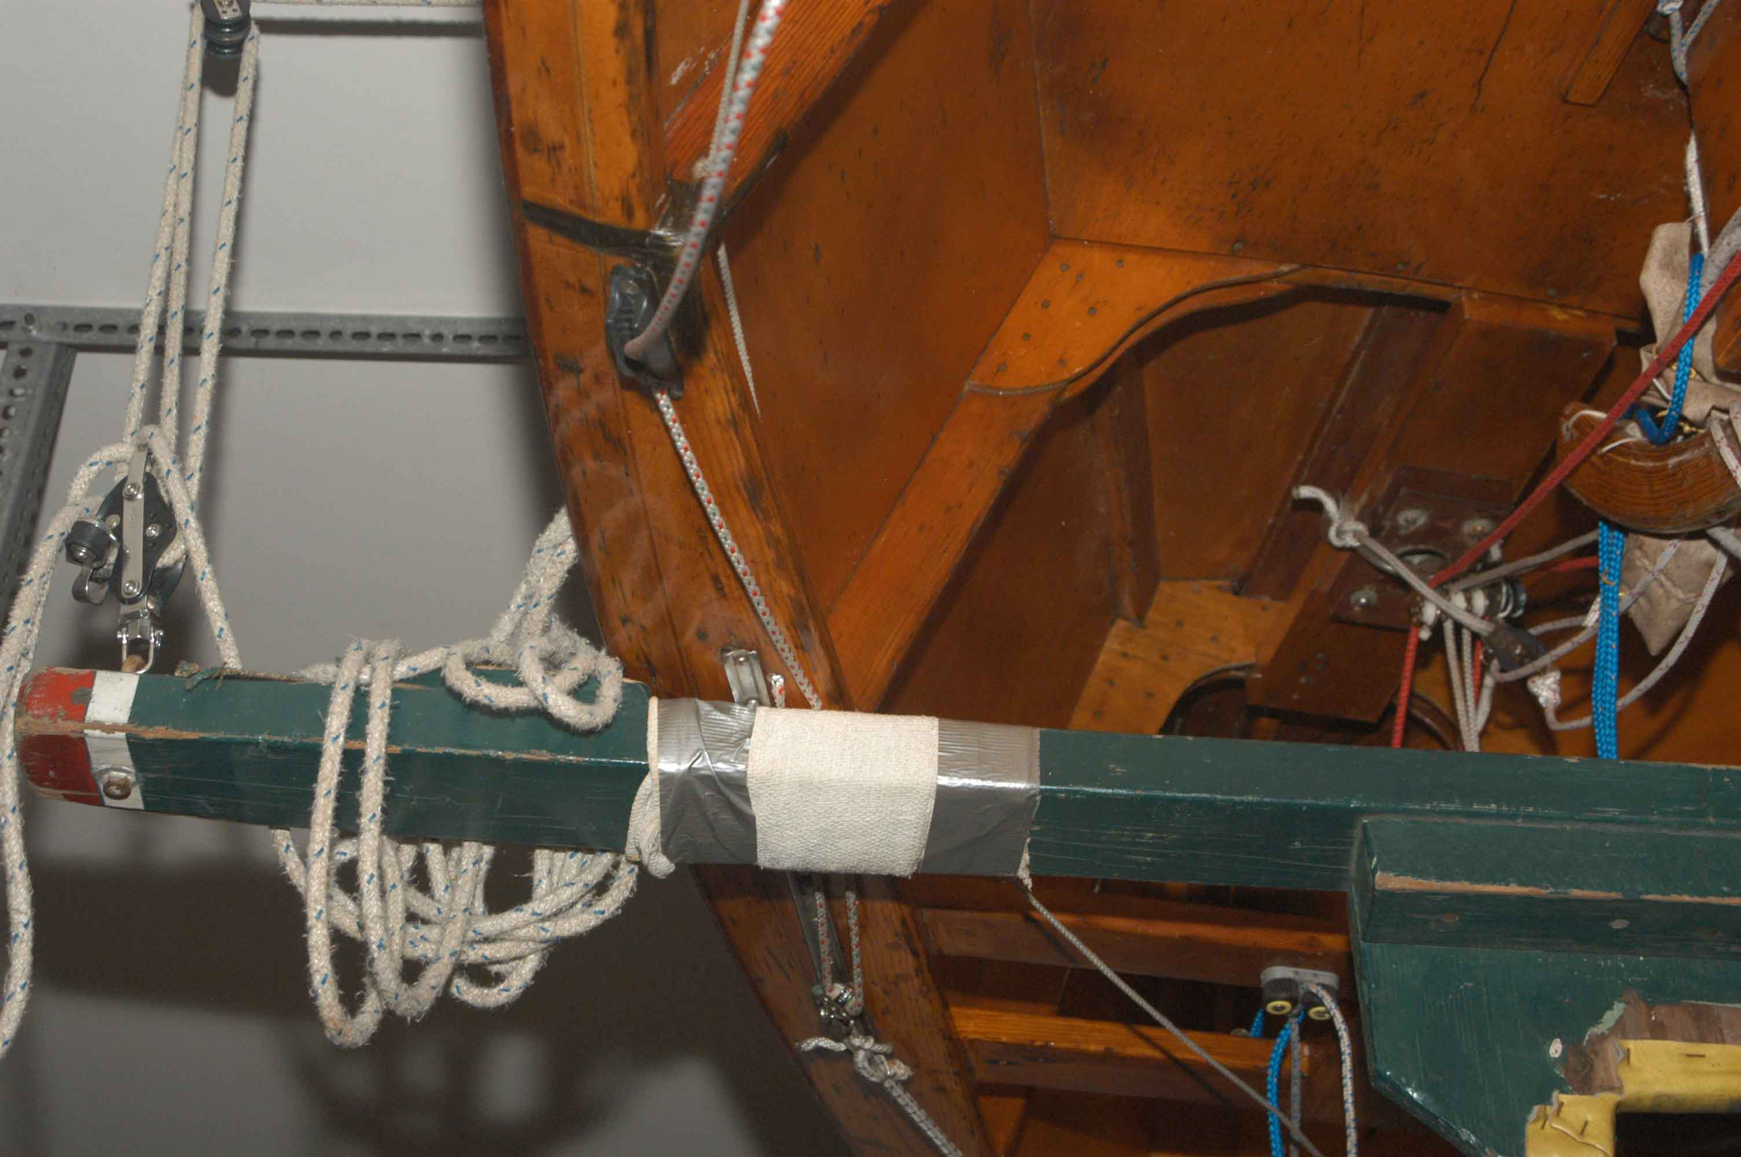
Upsided down view of shroud track and cleat (here mounted on top of rail). One upgrade is two-to-one control of shroud with single block mounted to slider and line dead-ended through hole in rail at inboard side and aft end of the shroud track.

To support the boom, I am not sure what your current arrangement is. Normally, you determine the height of the boom such that it is just below the black band (so that the sail can be pulled to the black band. The black band should be 16’ down from the upper black band on the mast – which is the highest point you raise the sail to. There is a piece of line tied to the boom jaw, which can be hooked through an eyestrap, or screw or something mounted on the front of the mast. You want to minimize how many holes you put in the mast, put you need a halyard lock or cleat and something to hold up the boom. The general rule is not to put any holes close to the mast partner as this is the highest stress area.

outhaul rigging: Normally you set the outhaul so the foot of the sail is about 6 to 8” from the boom at the midpoint, about the width of your outstretched hand, and forget it. Tighten it a little if the draft is too far aft on the sail, or it is blowing like stink and you really want to flatten the sail.

