.

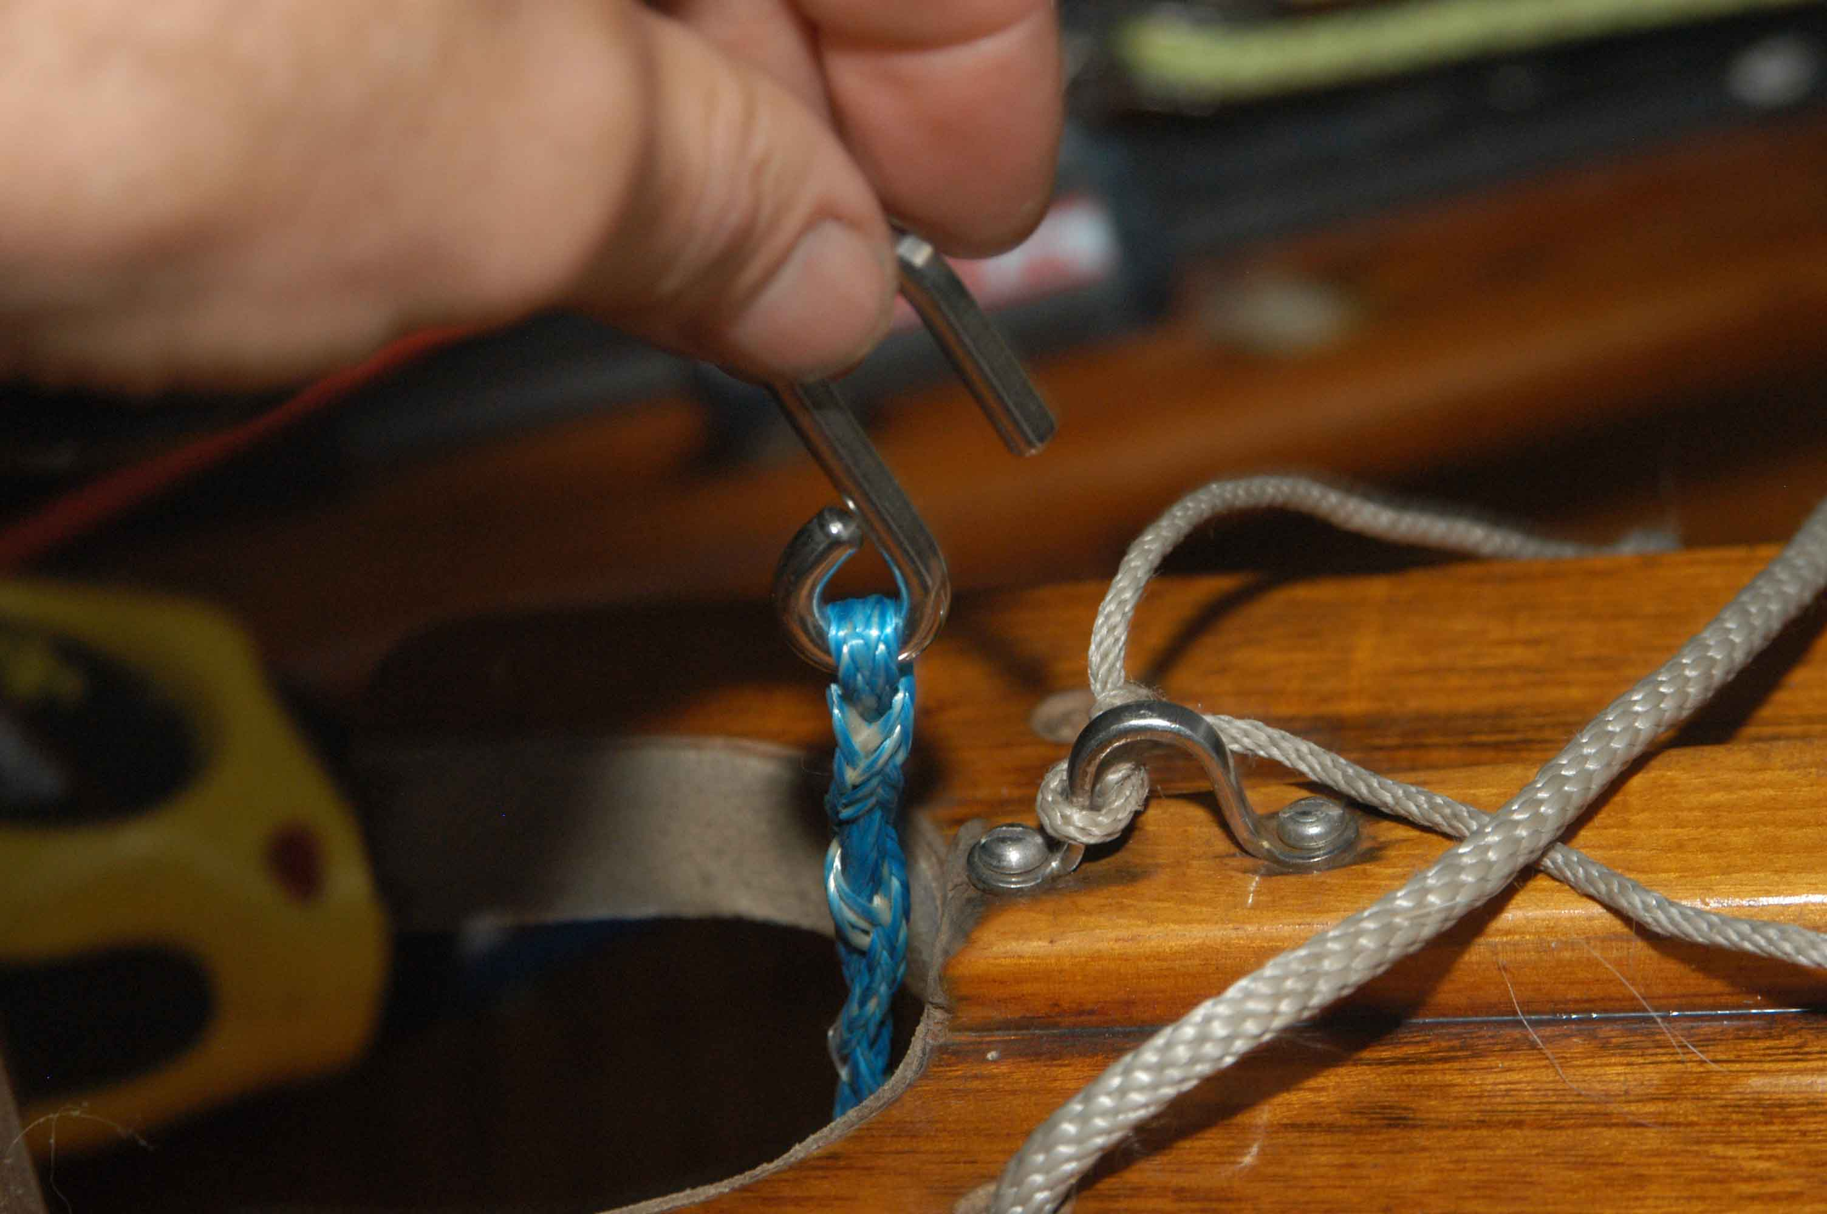

Cunningham – hook spliced to line. I drilled a hole through boom (where eye strap on boom was).

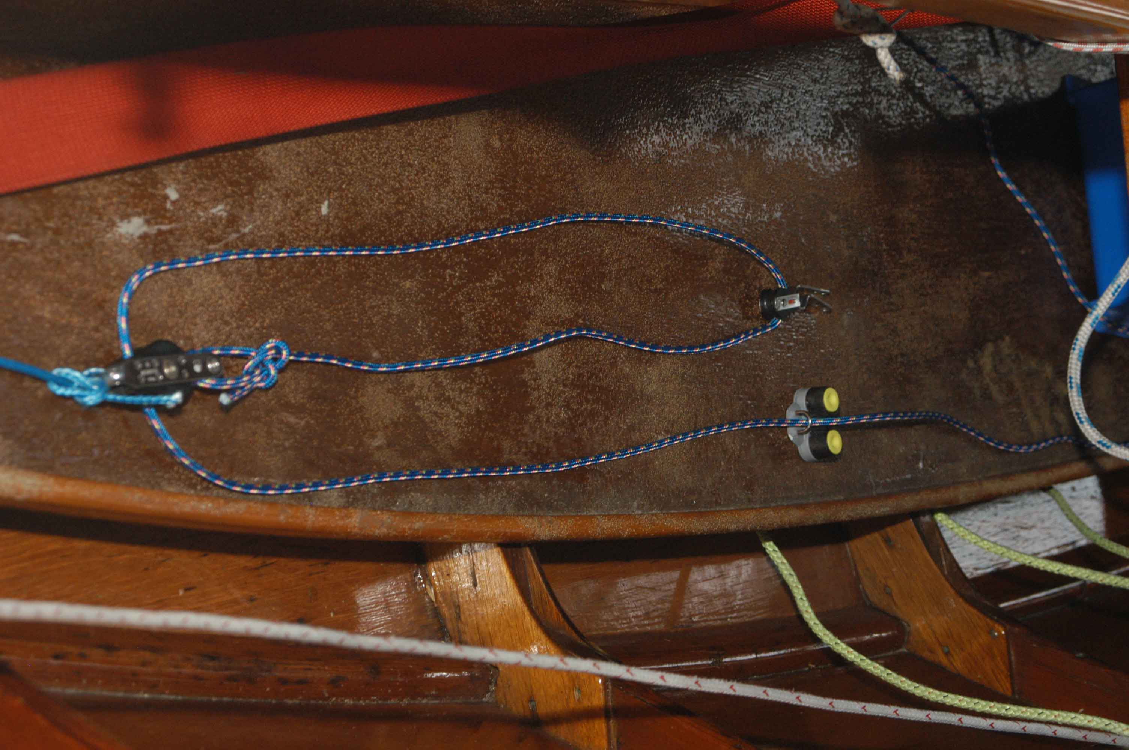

Rest of system for Cunningham. Will be on opposite side of boat from boom vang. Eye strap mounts under thwart and cleat at end of centerboard trunk. (I may have spliced an eye to attach low stretch line to bullet block with becket.

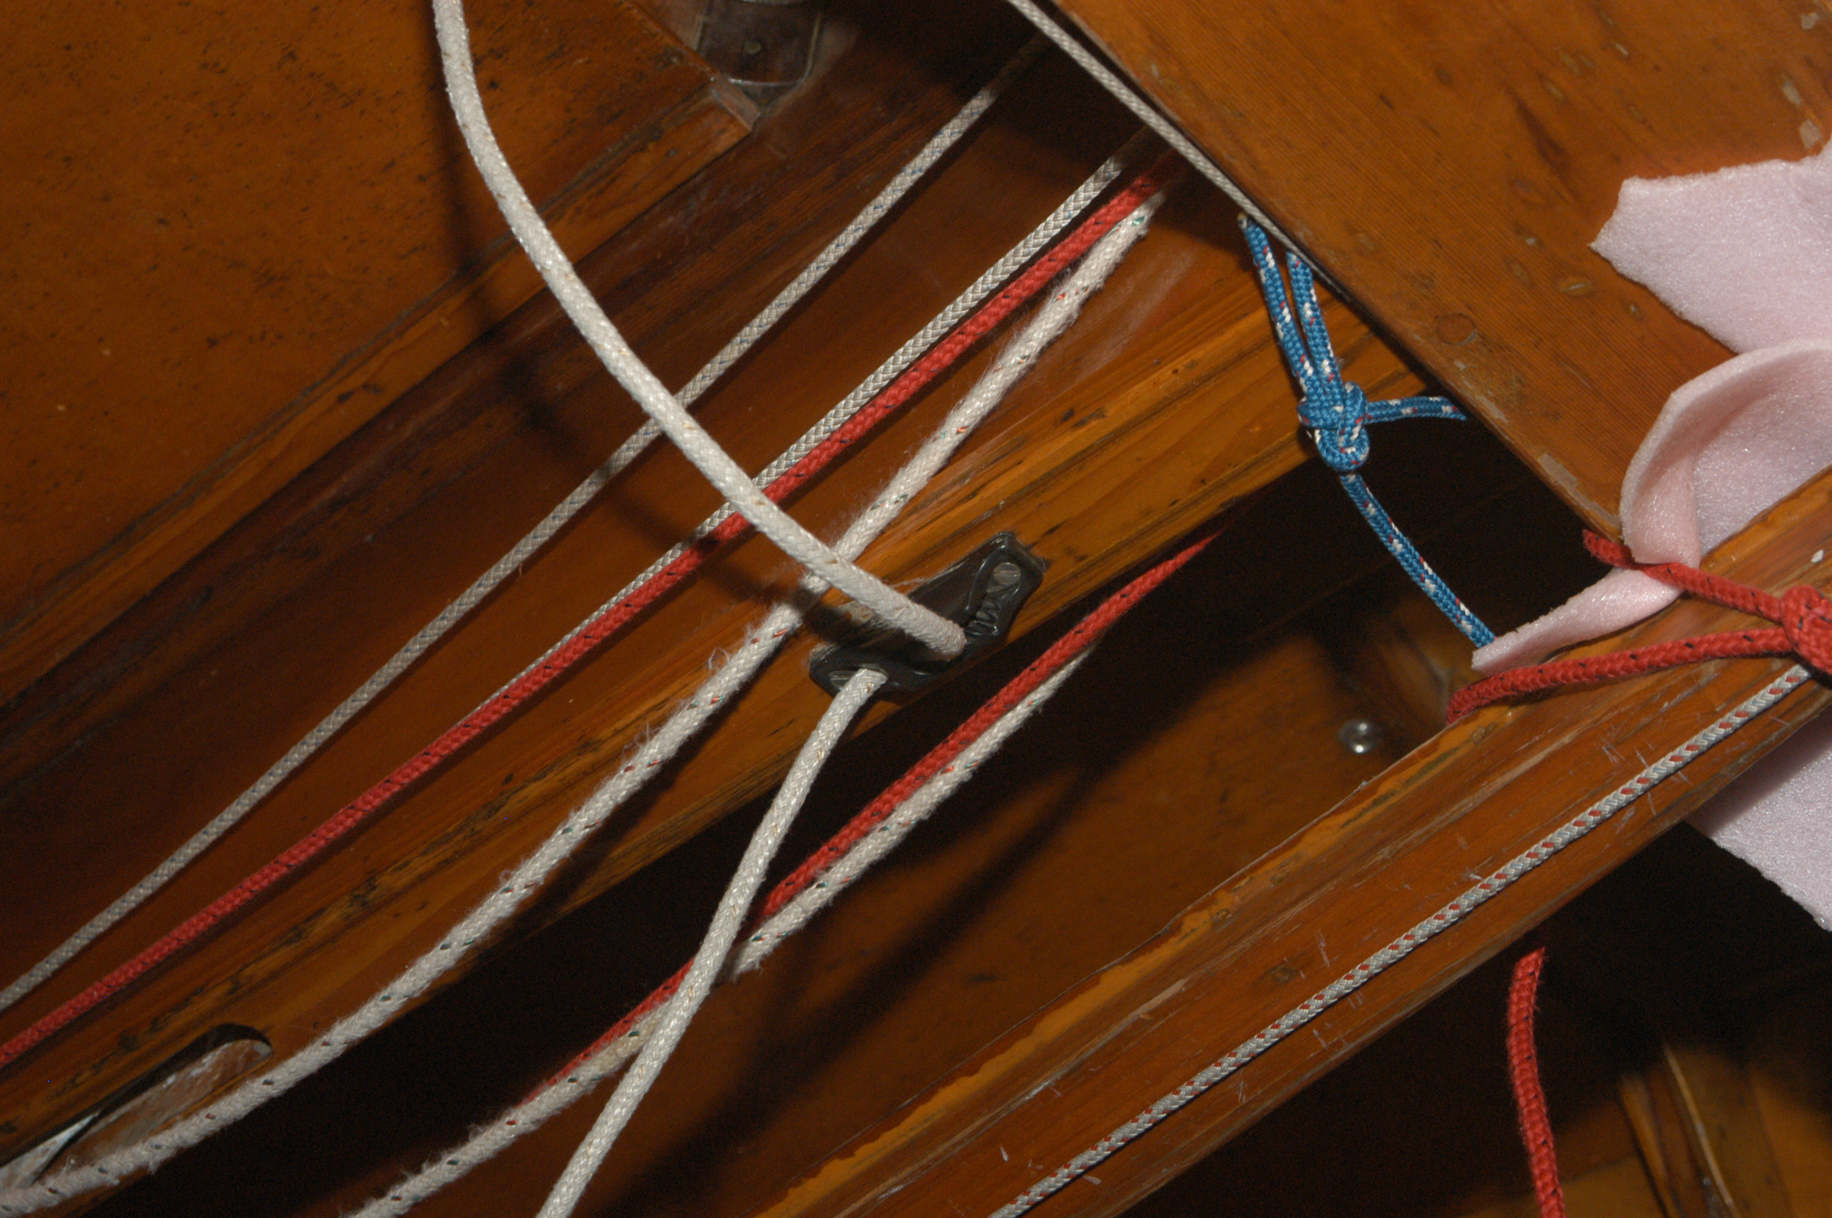

Alternative arrangement for centerboard cleat. I provided a similar cleat plus separate black fairlead which you might want to use if you want to use the cam cleat for the shroud or something.

There is a second cleat – black with a red round part, which I used to use for control lines (e.g. Cunningham).. Line is captive, and these work well at the end of the centerboard trunk (put in on the side where the cleat is toward the top.
It doesn’t matter which side you lead the vang and Cunningham to. I set the vang up to cleat on the starboard side, but this can be changed easily.

I am enclosing an additional boom bail. I’m not sure how the wire bridle will work. It might be fine for the mid boom sheeting, however if the arrangement bothers you, just take the bridle off and install the boom bail so it is located above the location of the mainsheet ratchet block.

Regarding the mainsheet ratchet block and cleat, Depending on the width of your centerboard trunk cap, you may have to mount the block on the thwart (unless you add something to widen the trunk cap (at least for the portion aft of the thwart).. I think I provided two sets of screws. The ones in the cleat are probably too long, and the other ones are probably too short, but that is what I was able to come up with. You could put a wood spacer under the cleat (3/8”) which would probably make the long screws appropriate.

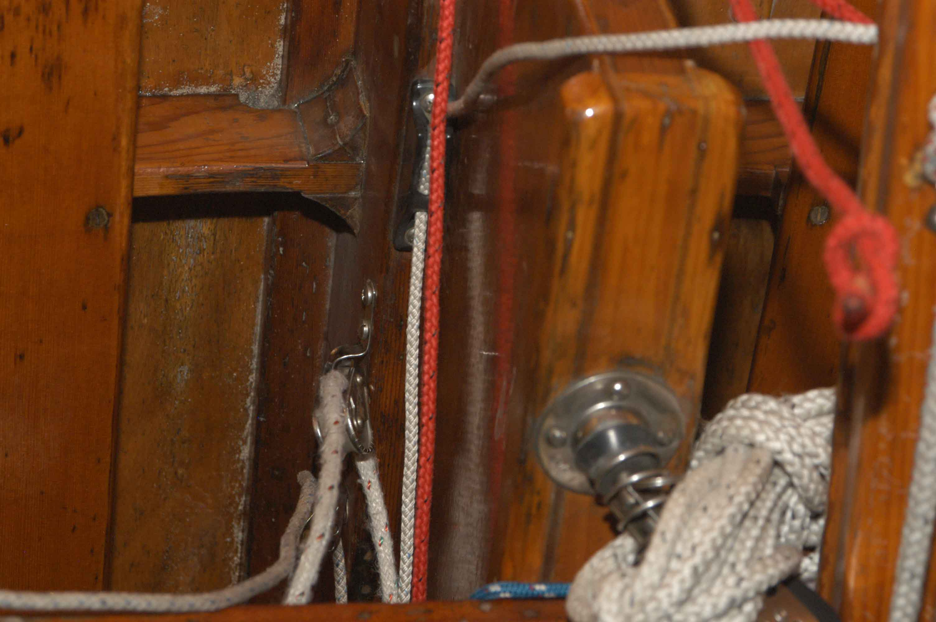

Upside down view of mainsheet block mounted on top of centerboard trunk. Note small strips along outside edge of trunk. Cleat can be mounted a few inches behind the block.

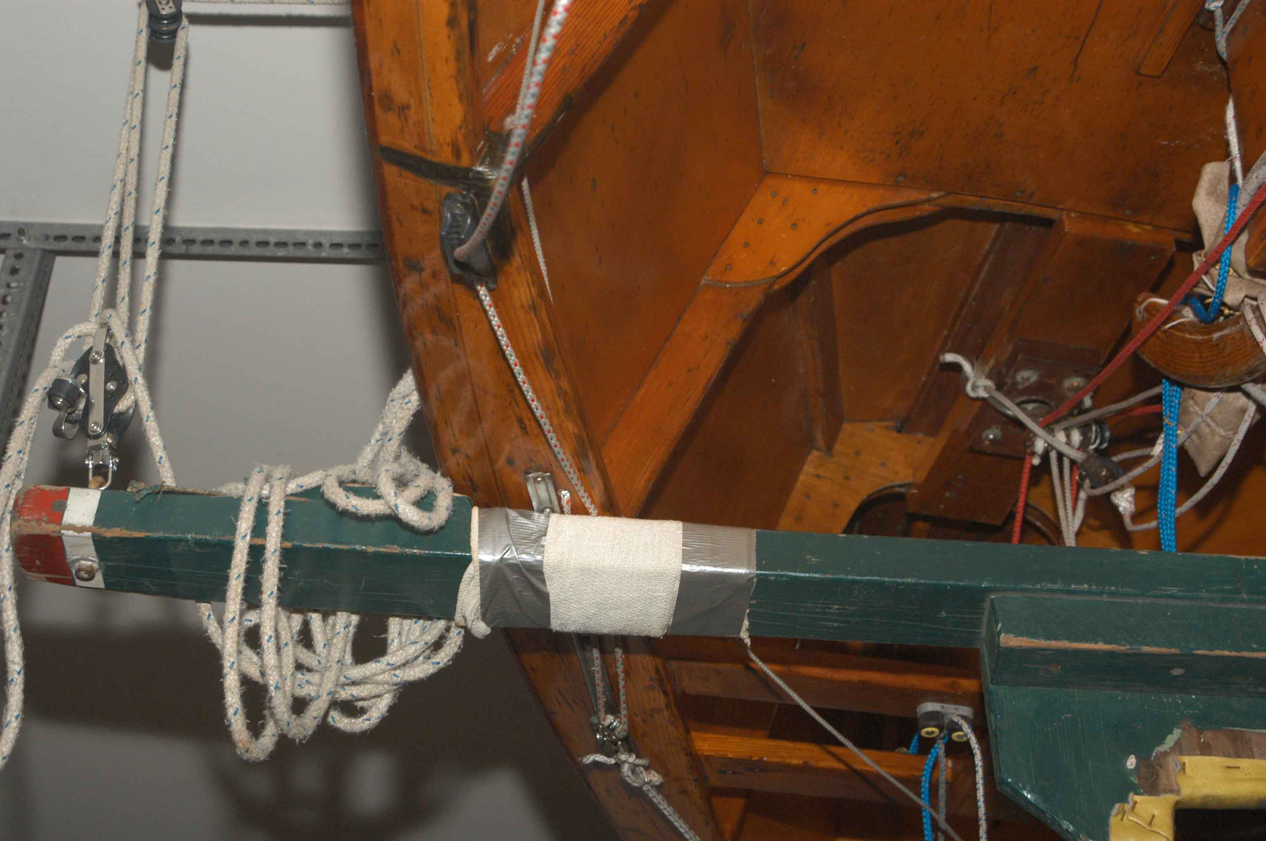
Upsided down view of shroud track and cleat (here mounted on top of rail). One upgrade is two-to-one control of shroud with single block mounted to slider and line dead-ended through hole in rail at inboard side and aft end of the shroud track.

Main halyard. Will have to see if this diameter holds up. I spliced both ends, but left the splice loose at the thimble end so you can remove the thimble, thread the line through the tube at the top of the mast, and reinsert the thimble and trim the length. The thimble location is such that the halyard lock should be installed on the mast just below the entry for the sail luff track. This way, you can attach the halyard without having to start the sail in the luff track. I bought the blue line (marstron) for the pull up part, but if there is enough green line, you may want to use the blue line for something else – it would make a good bow line since it is polypropylene and will float. It is also fine for its intended application, as the load is carried by the hi-tech line and it is easy on the hands. You’ll have to see if the halyard lock works. I tried it by knotting the two lines, but had trouble getting it to hold, so I spliced the line and added a thimble. The high tech line is easy to splice. I had a small fid, but you could do it with a knitting needle, or other round smooth small diameter object, pushing it through the line, and then passing the line through the hole you just opened up.

To support the boom, I am not sure what your current arrangement is. Normally, you determine the height of the boom such that it is just below the black band (so that the sail can be pulled to the black band. The black band should be 16’ down from the upper black band on the mast – which is the highest point you raise the sail to. There is a piece of line tied to the boom jaw, which can be hooked through an eyestrap, or screw or something mounted on the front of the mast. You want to minimize how many holes you put in the mast, put you need a halyard lock or cleat and something to hold up the boom. The general rule is not to put any holes close to the mast partner as this is the highest stress area.

Forestay. I purchased a turnbuckle with two swivel end fittings, as that was all they had. The turnbuckle thread is 10-32. One end is Right hand and the other left hand. Try threading either end on to the existing forestay end, and hopefully one will work, unless the thread size is wrong. Let me know if the turnbuckle and swivel fitting will fit through to the attachment point. I was hoping to find a non-swivel “fork-end” for the turnbuckle, which has a diameter close to that of the turnbuckle body and we don’t need the swivel feature anyway, but I couldn’t find it. I suspect we can order this if need be.

I ended up changing the outhaul rigging slightly, going with a wire and cleat, with no mechanical advantage. Normally you set the outhaul so the foot of the sail is about 6 to 8” from the boom at the midpoint, about the width of your outstretched hand, and forget it. Tighten it a little if the draft is too far aft on the sail, or it is blowing like stink and you really want to flatten the sail.

The sailing store didn’t have all the fasteners I needed, and I wasn’t able to get to the hardware store this morning – not enough gas in my wife’s car to get there – and I had to take that, as the boom and package will not fit in my car.

Let me know when you receive this and if you have any additional questions.
Charlie

