RULES
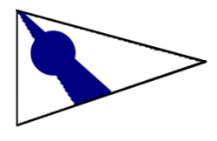 | SEVERN SAILING ASSOCIATION  NOTICE OF RACE AND SAILING INSTRUCTIONS 2005-2008 Edition, Version 1  311 First Street, Annapolis, Maryland 21403; (410) 269-6744; Website: www.severnsailing.org

The regatta will be governed by the Racing Rules of Sailing (RRS).

These instructions apply for regattas hosted by Severn Sailing Association (SSA) unless a separate notice of race and/or sailing instructions are published.

ENTRIES

Eligible boats may be entered by completing a registration form and paying any fees to the race committee by 1000 of the day of the first race for the entering boat.

Unless different fees are stated on the “Schedule and Results” section of the SSA website, or an amendment is posted, the entry fees are as stated in SSA’s Policies and Procedures, Section III-I.

NOTICES TO COMPETITORS

Notices to competitors will be posted on the official notice board located under the outer staircase on the lower level of the SSA clubhouse.

A competitors’ meeting may be held at 0930 on the first day of a regatta.

CHANGES TO SAILING INSTRUCTIONS

Changes to the sailing instructions made on the first day of the series will be posted within 15 minutes after the end of the competitor’s meeting.

When there is no competitors’ meeting, changes to the sailing instructions will be posted by 0930 except that any change in the schedule of races will be posted before 1900 on the day before it will take effect.

SIGNALS MADE ASHORE

Signals made ashore will be displayed on the flagpole in front of the SSA clubhouse.

When flag AP is displayed ashore, ‘1 minute’ is replaced with ‘not less than 60 minutes’ in the race signal AP.

SCHEDULE OF RACES

Five races are scheduled for a two-day weekend regatta. Three races are scheduled for a one-day series. Three races per day are scheduled for a multi-day regatta spread over more than one weekend.

The scheduled time of the warning signal for the first race each day is 1100.

On Sundays, no warning signal will be made after 1500.

CLASS FLAGS
Class flags will be a flag displaying the class insignia.

RACING AREAS
Racing will take place in areas "A", "B", or "C" as shown on Attachment 1. Racing will take place in Area "A" unless a notice is posted.

THE COURSES

Attachment 2 shows the courses, including the approximate angles between legs, the order in which marks are to be passed, and the side on which each mark is to be left.

No later than the warning signal, the race committee will display the course flag and the approximate compass bearing of the first leg.

No later than the warning signal, the race committee may display code flag “C” with several sound signals to indicate that mark 1 will be a new mark as described in instruction 10.2.

When the course flag is flown over the “2nd Substitute”, an offset mark to be rounded to port will be used in conjunction with mark 1. The offset mark will be placed at approximately a right angle to the weather leg and approximately 6-10 boat lengths to port of mark 1.

For courses D and G only, when the course flag is flown over the “3rd Substitute”, a separate finish line will be set in accordance with instruction 14.3.

A leeward gate, with marks set approximately 6-10 boat lengths apart, may be used without signal. When a gate is set, boats shall sail between the gate marks from the direction of the previous mark and round either gate mark.

MARKS

The rounding marks will be orange cylinders, except that an offset mark may be either an orange cylinder or sphere.

New marks, as provided in instructions 9.3 and 13, will be orange tetrahedrons.

CHECK IN

Each boat shall sail by the race committee signal boat, hail her sail number and be acknowledged by the race committee with a return hail of her sail number. This shall be done before a boat starts the first race in which she competes each day.

A boat failing to comply with the check-in procedure will receive, without a hearing, a 20% scoring penalty in the first race in which the boat competes calculated as stated in rule 44.3(c). This changes rule 63.1 and A4.

THE START

Races will be started by using rule 26, unless code flag “3” is displayed prior to the warning signal.

When code flag “3” is displayed, races will be started by using Appendix Q (Sound signal starting system).

The starting line will be between a staff or halyard displaying an orange flag on the race committee signal boat and the course side of the pin end mark. The pin end mark will either be mark 3 or a yellow cylinder offset to leeward of mark 3.

Boats whose warning signal has not been made shall avoid the starting area.

A boat starting later than 10 minutes after her starting signal will be scored Did Not Start. This changes rule A4.
ATTACHMENT 1 – RACING AREAS
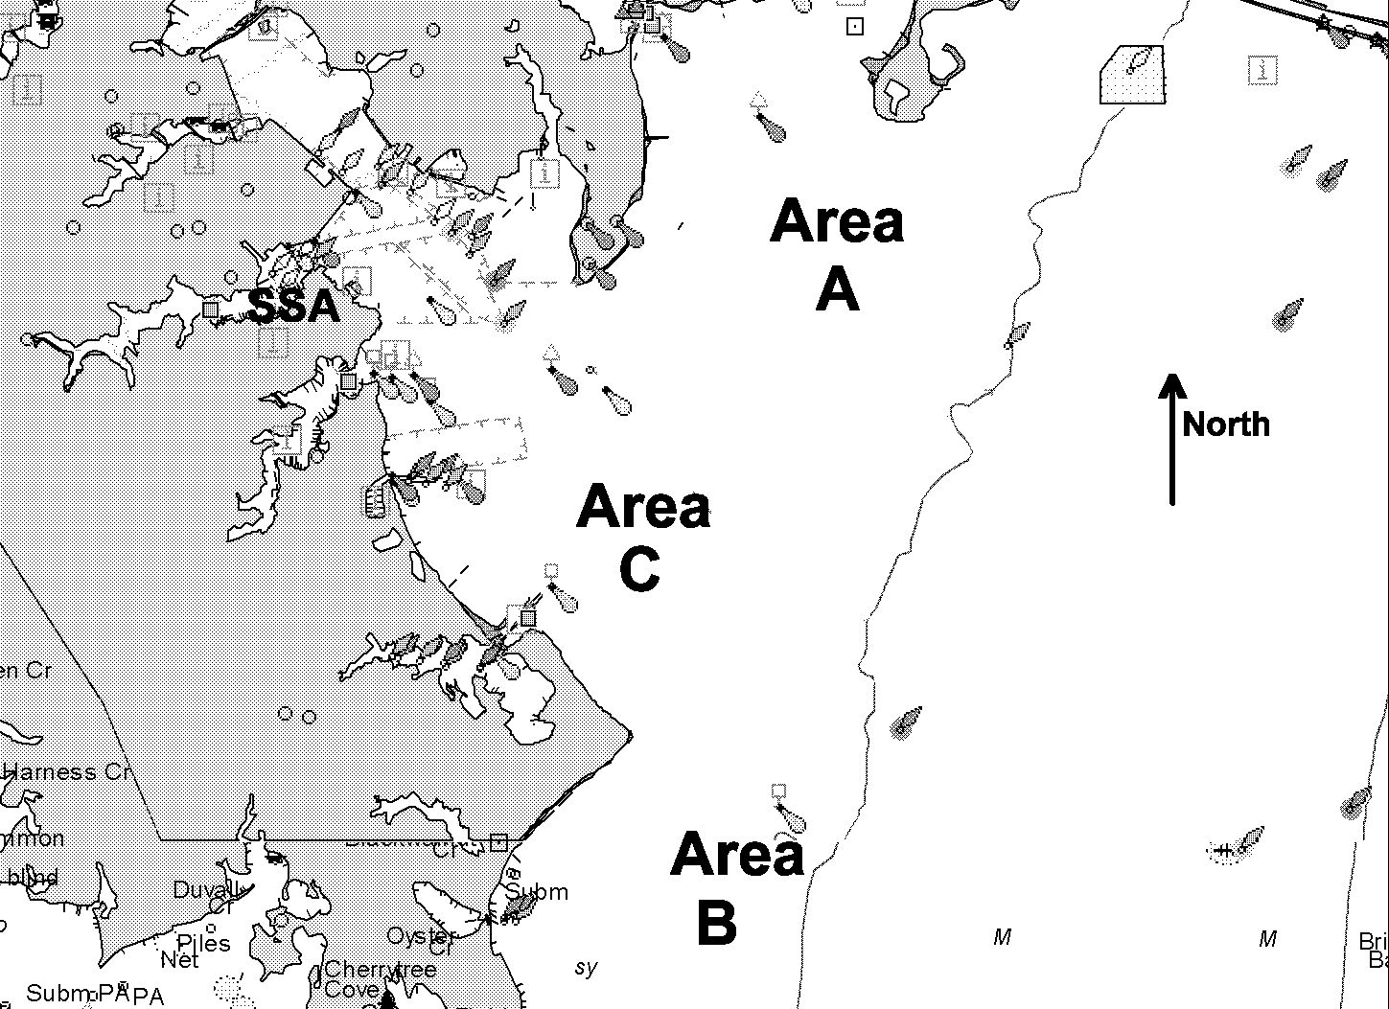

When rule 29.1 applies, the race committee intends to hail premature starters. The following will not be grounds for redress: failure of the race committee to hail any sail or hull numbers; failure of a boat to hear a hail; a boat's position in the sequence of hails; promptness of the hail. This changes rule 62.1(a). Unless a notice is posted, the hail will be oral.

CHANGE OF THE NEXT LEG OF A COURSE
To change the next leg of the course, the race committee will lay a new mark, signal in accordance with rule 33, and remove the original mark as soon as practicable. When in a subsequent change a new mark is replaced, it will be replaced by an original mark.

THE FINISH

For courses T, W, and O, the finishing line will be between a staff or halyard displaying an orange flag on the race committee finish boat and the course side of mark 1.

For courses D and G without 3rd substitute, the finishing line will be between a staff or halyard displaying an orange flag on the race committee boat and the course side of the starting mark.

For courses D and G with 3rd substitute, the finishing line will be between a staff or halyard displaying an orange flag on the race committee finish boat on the starboard end and the course side of an orange cylinder or sphere on the port end.

TIME LIMITS

Time limit is 2 hours for each class.

Boats that have not finished and are still racing 30 minutes after the first boat finishes will be scored as 'Time Limit Expired’ (TLE) and will be scored two points more than number of finishers, however no boat will receive a score worse than the number of points awarded a DNF. This changes rule 35 and Appendix A.

The race committee will abandon a race when it is unlikely that all boats will be able to finish and return to the harbor before sunset.

PROTESTS AND REQUESTS FOR REDRESS

Protest forms are available at the protest desk inside the 2nd deck of the SSA clubhouse. Protests shall be delivered there within the protest time limit.

The protest time limit is 60 minutes after the arrival of the race committee signal boat at the dock. The same time limit applies to protests by the race committee and protest committee about incidents they observe in the racing area and to requests for redress. This changes rules 61.3 and 62.2.

The race committee will post its official arrival time on the notice board and will hoist code flag “B” during the protest filing period. Code flag “B” will be lowered with one sound signal at the protest time limit.

Notices will be posted on the notice board within 30 minutes of the protest time limit to inform competitors of hearings in which they are parties or named as witnesses. Hearings will be held on the 2nd floor of the SSA clubhouse unless an alternate location is posted with the hearing notices.

Notices of protests by the race committee or protest committee will be posted to inform boats under rule 61.1(b).

For the SSA Spring Series, Summer Series, and Fall Series, hearings will be scheduled on the next Thursday beginning at 1930.

Rule 44.1 is changed by adding: “A boat breaking a rule of Part 2 of the RRS may take a penalty any time after the incident and before the start of a protest hearing by taking a 40% Scoring Penalty as calculated in rule 44.3(c).”

The penalties for breaking instructions 12.4, 18.1, and 19 may be less than disqualification if the protest committee so decides.

On the last day of the regatta a request for reopening a hearing shall be delivered:

within the protest time limit if the party requesting reopening was informed of the decision on the previous day;

no later than 30 minutes after the party requesting reopening was informed of the decision on that day. This changes rule 66.

SCORING
Regattas will be scored in accordance with the Low Point System of Appendix A, modified such that a boat’s series score will be the total of all her race scores.

SAFETY REGULATIONS

A boat that retires from a race or leaves the racing area prior to the end of racing shall notify the race committee as soon as practical. The race committee can be notified by contacting any race committee boat verbally, or by VHF channel 65A or by telephone at (410) 269-6744.

A boat shall carry all equipment required by her class rules. If not so specified, she shall also carry one USCG approved PFD, of the appropriate class, for each person on board.

All boats shall have available an appropriate line, not less than 25 feet long, which can be used for towing.

Appropriate protective clothing shall be worn by competitors from 15 November through 15 March and at all other times that the water temperature is below 60F. Wetsuits or dry-suits may be appropriate for this purpose, but skippers are solely responsible for the safety of their crew, their vessel and themselves.

The race committee may carry out checks of safety equipment required in instruction 18 or class rules.

TRASH DISPOSAL
Boats shall not put trash in the water.

COMMERCIAL TRAFFIC

A boat may not exercise right of way, cross in proximity to, or interfere with reasonable transit of the race area by commercial ships, tugs, or barges. Boats must take evasive action well in advance of a potentially dangerous situation. The US Coast Guard, ship captains, and bay pilots have been encouraged to report any incident they observe.

Rule 60.1 is changed so that only the race committee or protest committee may protest a boat under this rule. For such protests:

Rules 60.2 and 60.3 are changed such to permit a protest based on information received from any source.

Rule 61.3 is changed such that there is no time limit for filing the protest.

Rule 64.1 is changed such that the protested boat has the burden of proof that they did not break this rule.

RADIO COMMUNICATION
A boat shall neither make radio transmissions while racing nor receive radio communications not available to all boats. This restriction also applies to mobile telephones.

PRIZES
Prizes will be awarded to the skippers and crews placing first, second, and third in the regatta. Additional prizes may be awarded at the discretion of the organizing authority.

DISCLAIMER OF LIABILITY
Competitors participate in the regatta entirely at their own risk. See rule 4, Decision to Race. The organizing authority will not accept any liability for material damage or personal injury or death sustained in conjunction with or prior to, during, or after the regatta.

(Version 1.0, March 23, 2005)

ATTACHMENT 2 – COURSES
see also instructions 9 (Courses), 12 (The Start), and 14 (The Finish)
Course | Diagram | Course | Diagram
  Options | Diagram
    Flag “2nd Sub.”:  Offset at Mark 1  (SI 9.4) | 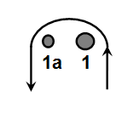
    Flag “C” at Start:  (SI 9.3) | 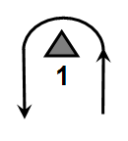
  Gate  (SI 9.6) | 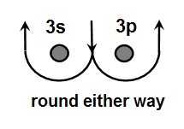
  
  Flag “3rd Sub.”:
  Split Start/Finish Line
  (SI 9.5 and 14.3)
  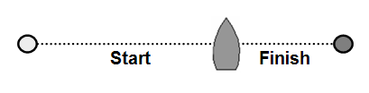
  Flag "W": Start – 1 – 3 – 1 – 3 - Finish | 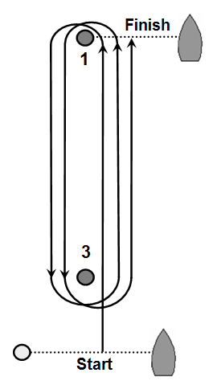 |   Flag "D" : Start – 1 – 3 – 1 – Finish | 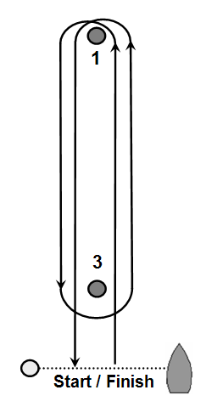
  Flag "O": Start – 1 – 2 – 3 – 1 – 3 - Finish | 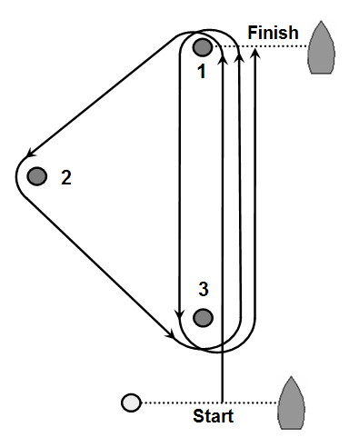 |   Flag "G": Start – 1 – 2 – 3 – 1 - Finish | 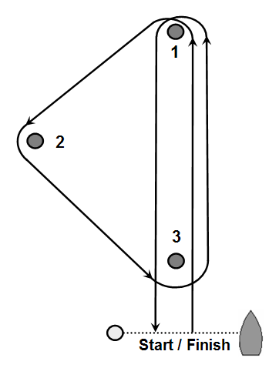
  Flag "T": Start – 1 – 2 – 3 – Finish | 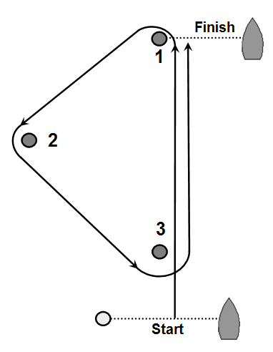 |   Flag “3” | Appendix “Q”, 3-minute sound-system starting sequence

