.

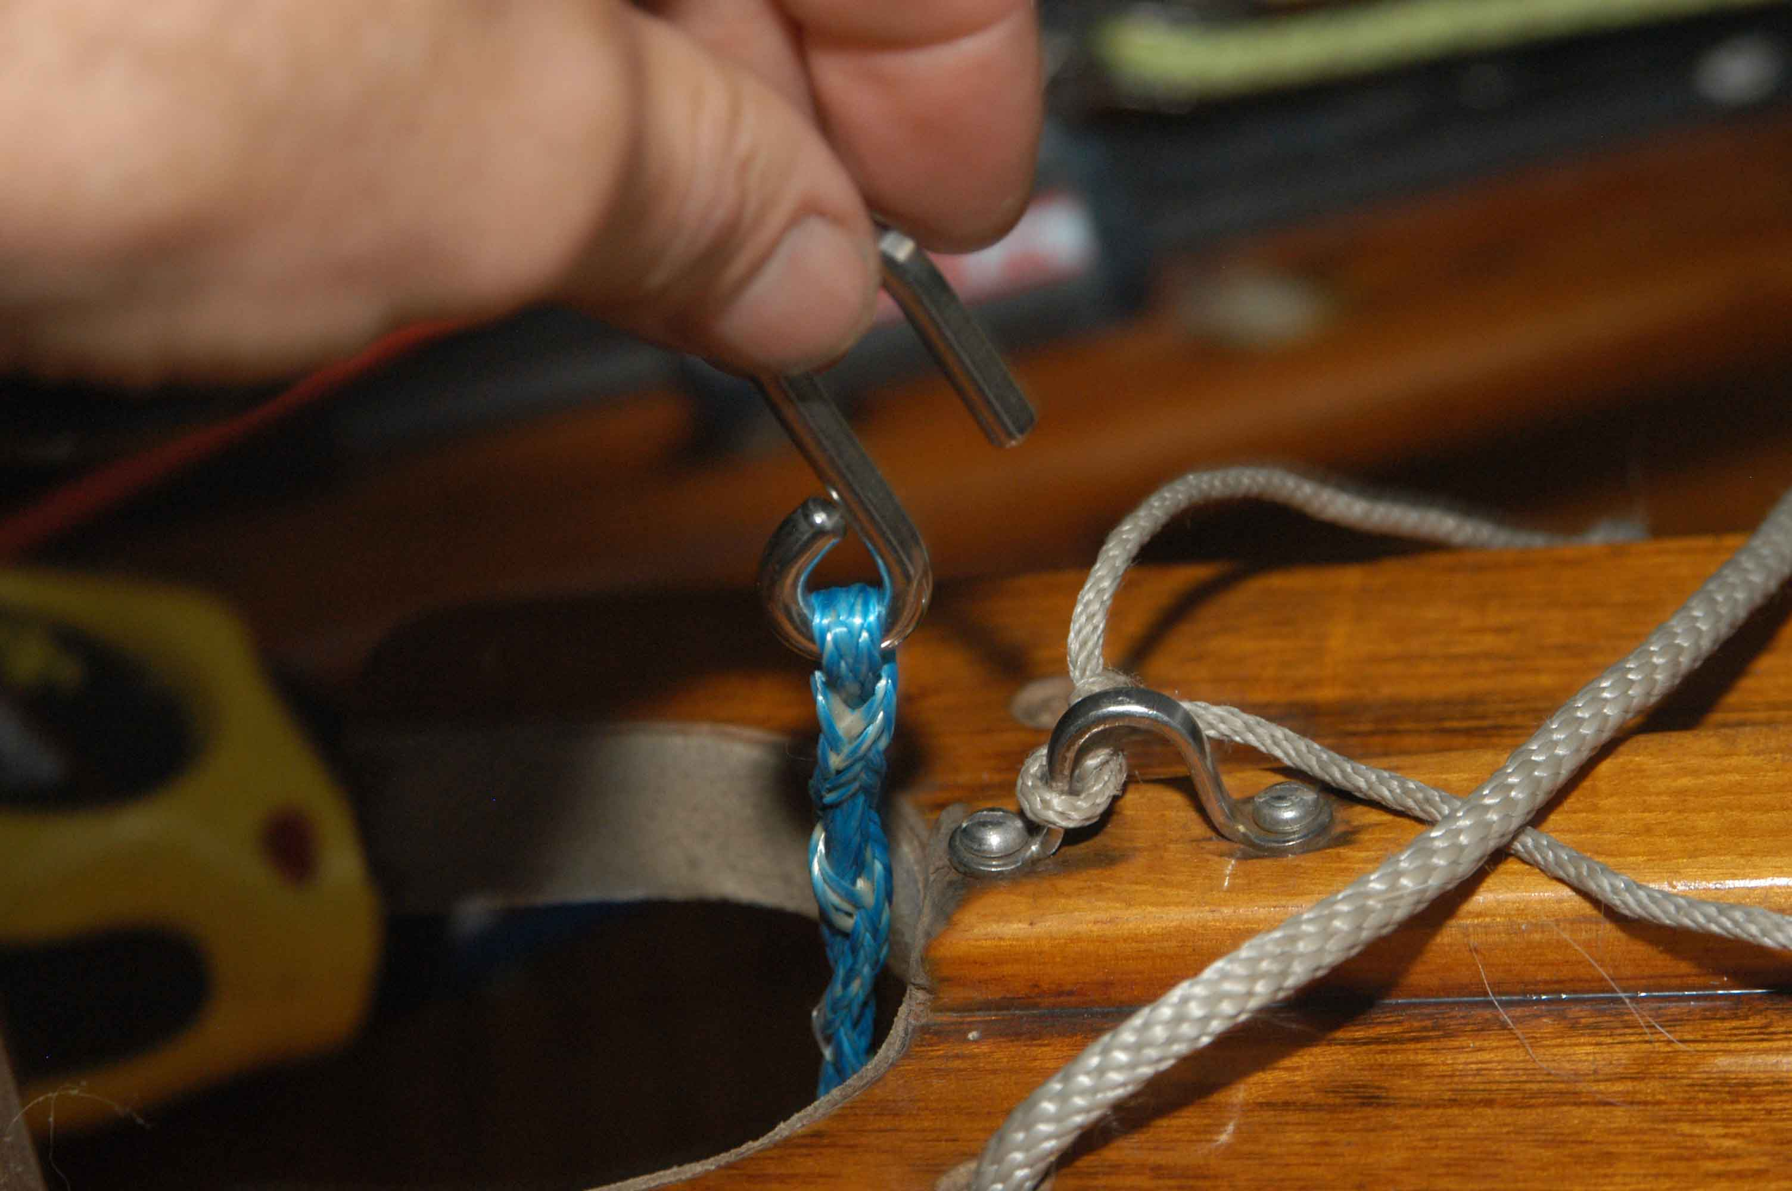

Cunningham – hook spliced to line.
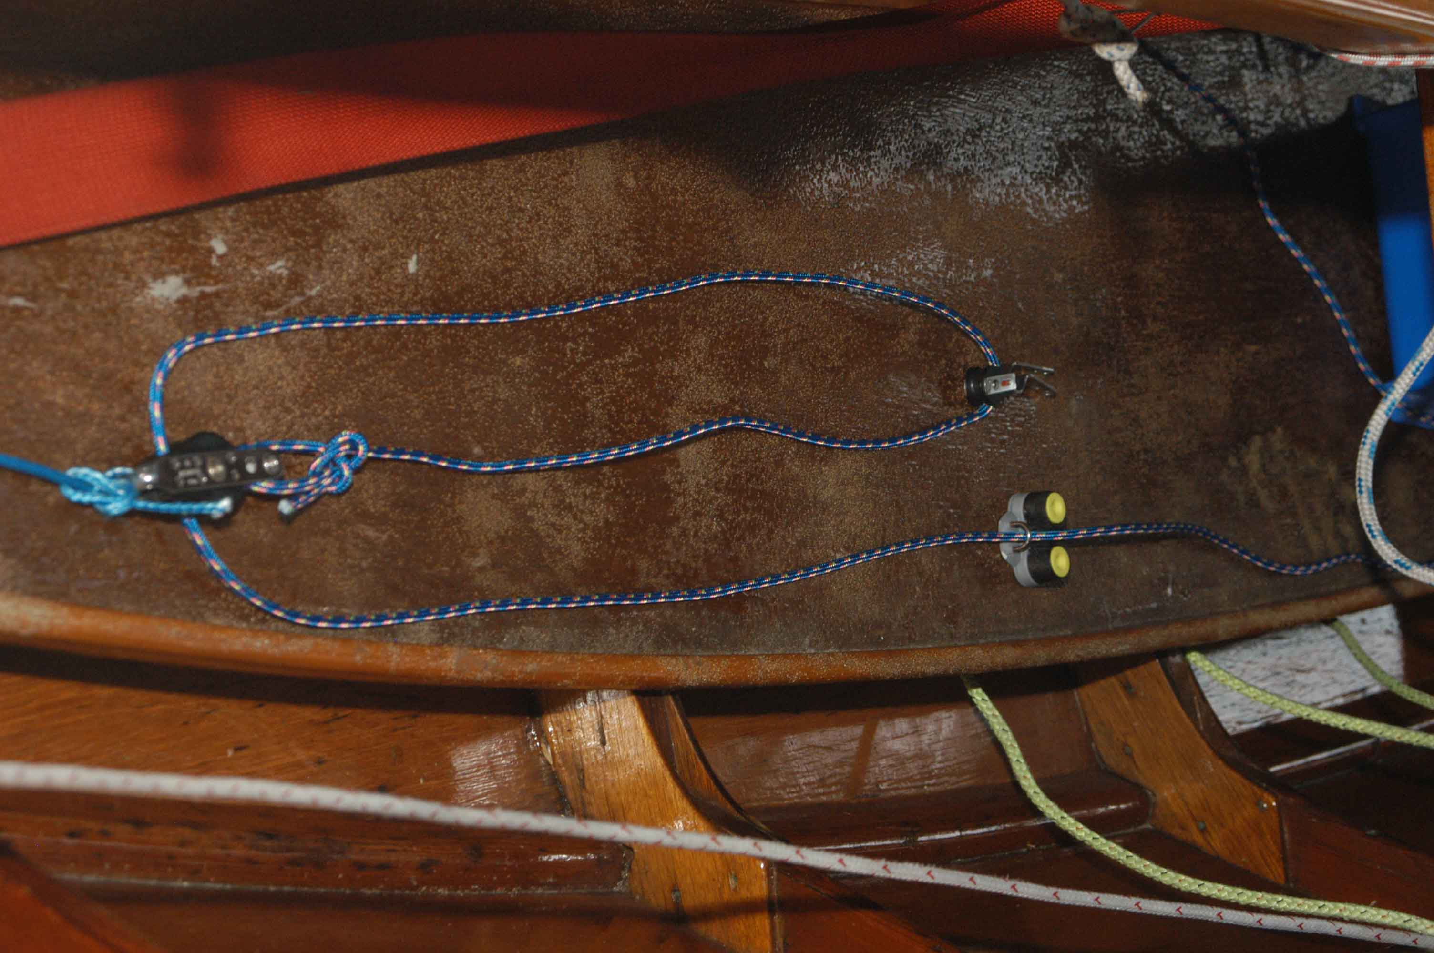

Rest of system for Cunningham. Will be on opposite side of boat from boom vang. Eye strap mounts under thwart and cleat at end of centerboard trunk.

